Assignment # 2

Gavyn Gallagher

# Problem 1

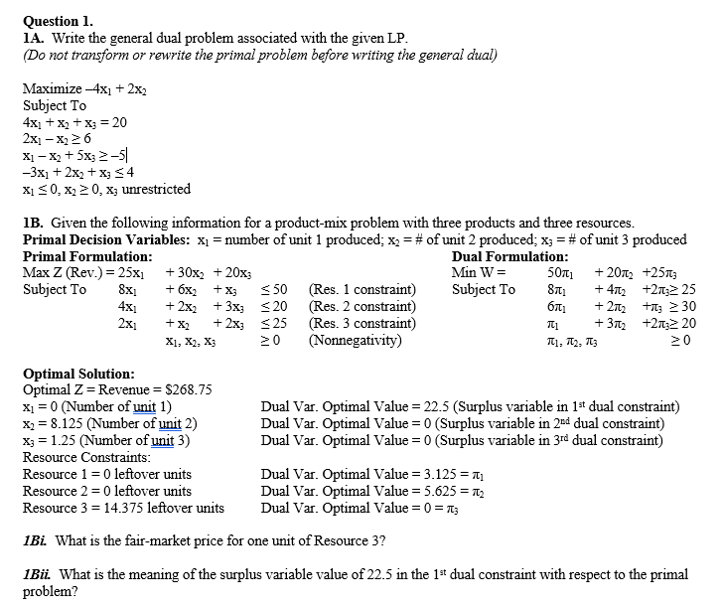

## 

## 1A.

Minimize Z = 20y1 + 6y2 - 5y3 + 4y4

Variables:

* y1
* y2
* y3
* y4

Constraints:

* 4y1 + 2y2 + 1y3 - 3y4 <= -4
* 1y1 - 1y2 - 1y3 + 2y4 >= 2
* 1y1 + 5y3 + 1y4 = 0 # = sign since x3 is unrestricted
* y1 is unrestricted
* y2,y3 <= 0
* y4 >= 0

1B.

1Bi. Dual values aka shadow values represent the value gained of an additional unit to the right-hand side of a constraint. The dual variable optimal value of resource 3 is 0. Meaning adding to resource 3 would not do anything. The fair market price would be $0 .

1Bii. The surplus variable aka reduced cost value of 22.5 means that for an additional unit of x1 that profit would decrease by $22.5

# Problem 2

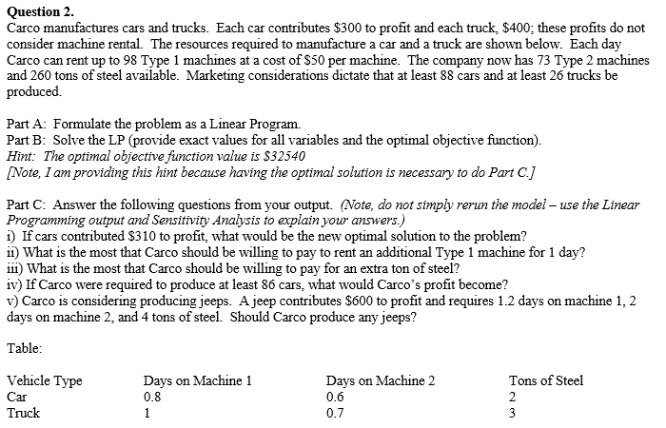

Part A:

Objective function : Z = 300*Car + 400*Truck - 50*Machine1

Constraints:

* 0.8*Car + 1*Truck - 1*machine1 <= 0
* Machine1 <= 98
* 0.6*Car + 0.7*Truck <= 73
* 2*car + 3*Truck <= 260 #steel
* Truck >= 26 # marketing considerations
* Car >= 88 # marketing considerations
* Car, Truck, Machine1 >= 0

Part B:

* Car optimal value: **88**
* Truck optimal value: **27.6**
* Machine1 optimal value : **98**
* Maximum profit : **$32,540**

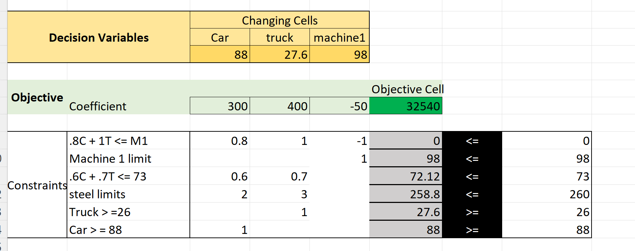

Part C:

i) (310*88) + (27.6*400) - (50*98) = **$33420**

ii) The allowable increase is 0.4 units and cannot add an additional unit

iii) $0. Do not pay for additional steel as its a non binding constraint.

iv) The shadow price is negative. Meaning producing more will hurt profit, while producing less will increase the profit.86 is less than 88. -20*-2 = 40. 32,540 + 40 = **$32,580**

v) With jeep added to the equation. The Optimal units for Jeep is 0.76 < 0. Meaning less than 1 unit produced is optimal. Adding Jeeps would not benefit the equation.

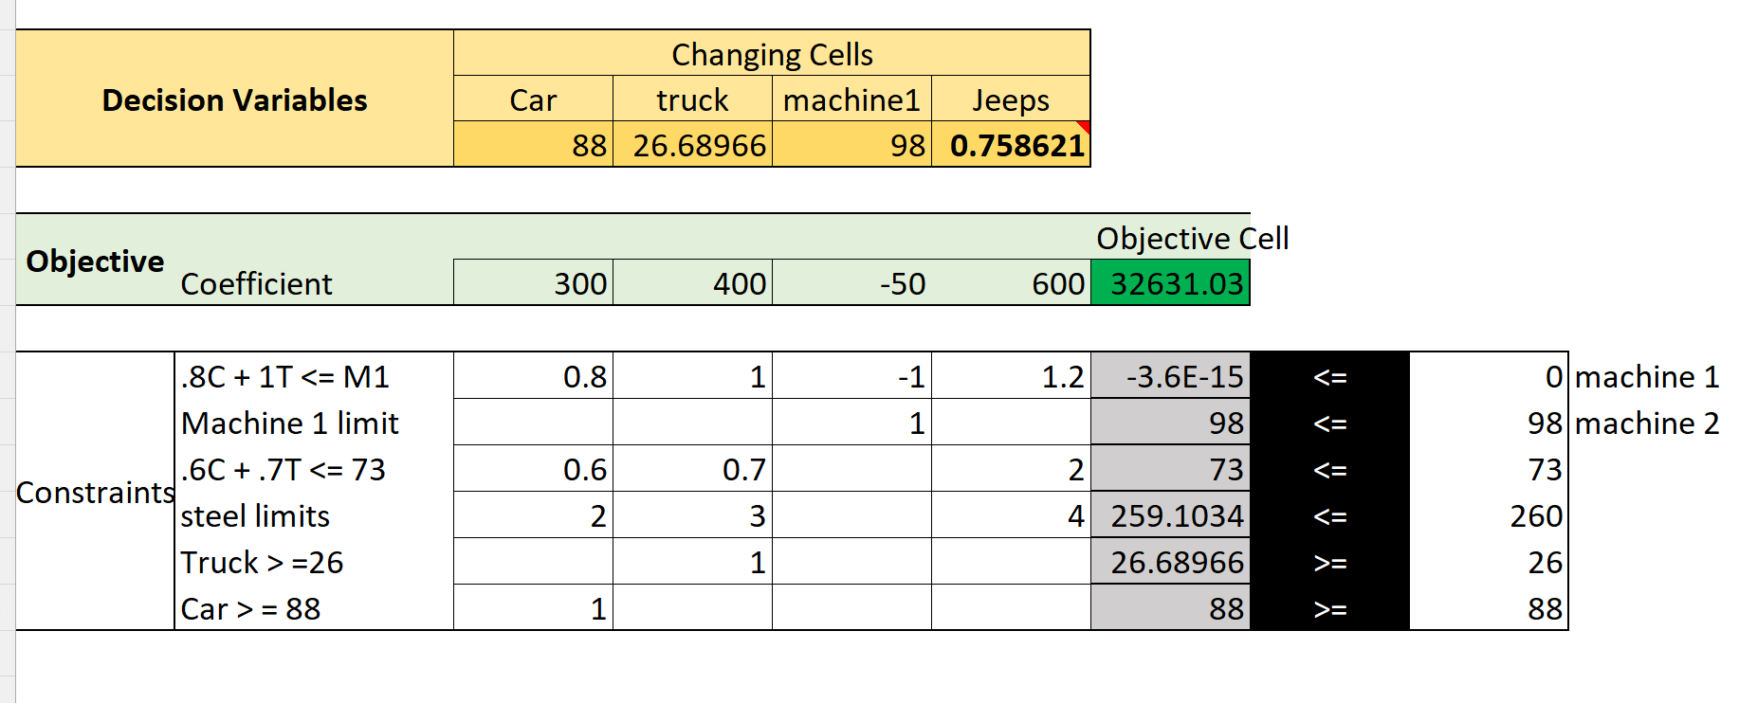

# Problem 3

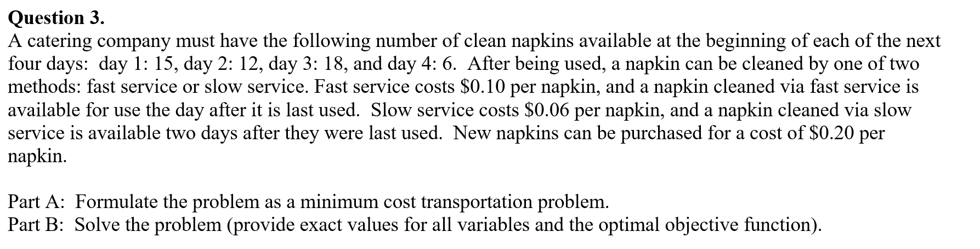

PART A:

Number represents the day of purchase or cleaning

Start out with 0 napkins, have to buy all the ones for day 1

Variables

* B1
* F1
* S1
* B2
* F2
* S2
* B3
* F3
* S3
* B4

Conntraints

* B1 >= 15 # day 1
* B2+F1 >= 12 # day 2
* B3 + F2 + S1 >= 18 # day 3
* B4 + F3 + S2 >= 6 # 4
* B1- F1 - S1 >= 0 # B1 >= F1 + S1
* B2+F1>=F2+S2
* B3+S1+F2>=F3+S3

Objective function:

* .20*(B1 + B2 + B3 + B4) + .10(F1+ F2+F3) + 0.6(S1+S2+ S3)

PART B:

Answers

Objective function : **6.66**

* B1 = **15**
* F1 = **9**
* S1 = **6**
* B2 = **3**
* F2 = **12**
* S2 = **0**
* B3 = **0**
* F3 = **6**
* S3 = **0**
* B4 = **0**

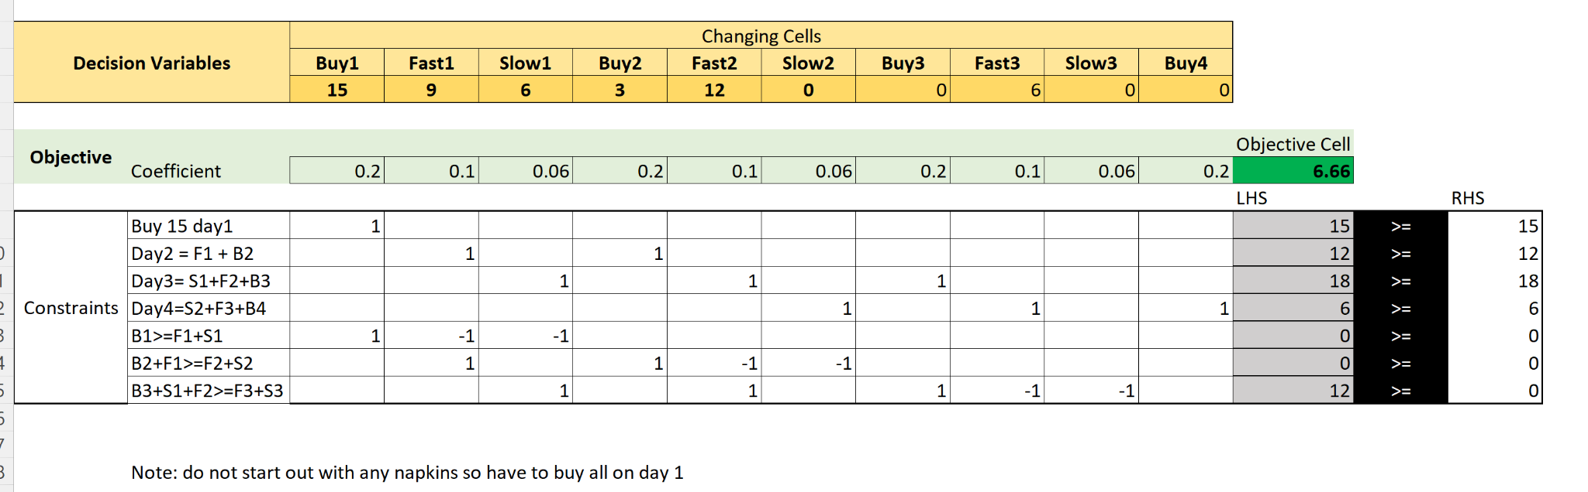

# Problem 4

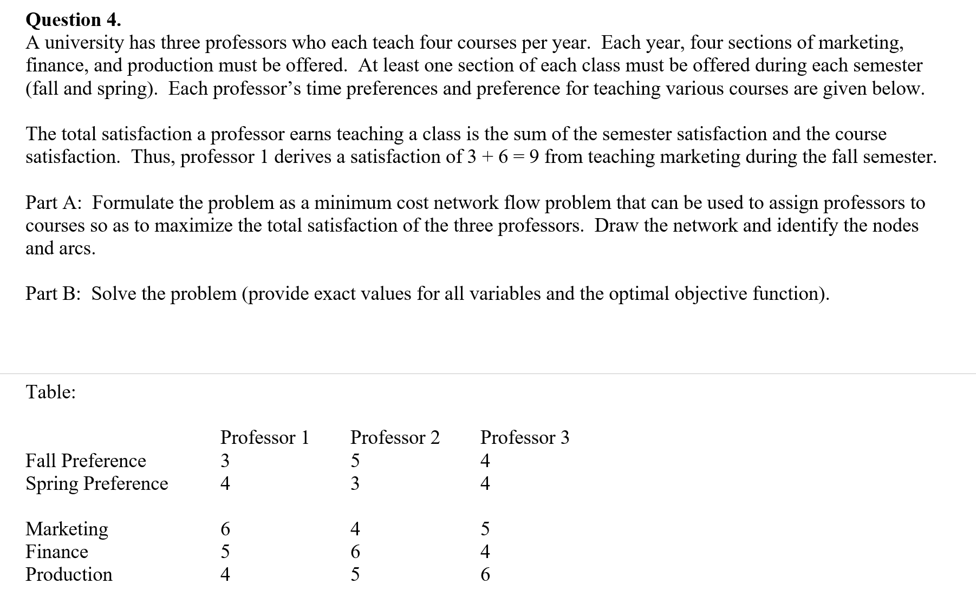

PART A:

F or M, the second value in th sequence, represents fall or spring. M, F, P represents marketing, finance, production. 1,2,3 represents the professors.

Variables

| * FM1 * FF1 * FP1 * SM1 * SF1 * SP1 | * FM2 * FF2 * FP2 * SM2 * SF2 * SP2 | * FM3 * FF3 * FP3 * SM3 * SF3 * SP3 |
| --- | --- | --- |

Constraints

* At least one section of each class be offered each semester
  + FM1 + FM2 + FM3 >=1
  + FF1 + FF2 + FF3 >=1
  + FP1 + FP2 + FP3 >=1
  + SM1 + FM1 + FM1 >=1
  + SF1 + SF1 + SF1 >=1
  + SP1 + SP1 + SP1 >=1
* Each year, 4 sections of each class must be offered
  + FM1 + FM2 + FM3 + SM1 + SM2 + SM3 = 4
  + FF1 + FF2 + FF3 + SF1 + SF2 + SF3 = 4
  + FP1 + FP2 + FP3 + SP1 + SP2 + SP3 = 4
* Each professor teaches 4 classes
  + FM1 + FF1 + FP1 + SM1 + SF1 + SP1 = 4
  + FM2 + FF2 + FP2 + SM2 + SF2 + SP2 = 4
  + FM3 + FF3 + FP3 + SM3 + SF3 + SP3 = 4

Objective function: 9*FM1 + 8*FF1 + 7*FP1 + 10*SM1 + 9*SF1 + 8*SP1 +

9*FM2 + 11*FF2 + 10*FP2 + 7*SM2 + 9*SF2 + 8*SP2 +

9*FM3 + 8*FF3 + 10*FP3 + 9*SM3 + 8*SF3 + 10*SP3

Diagram:

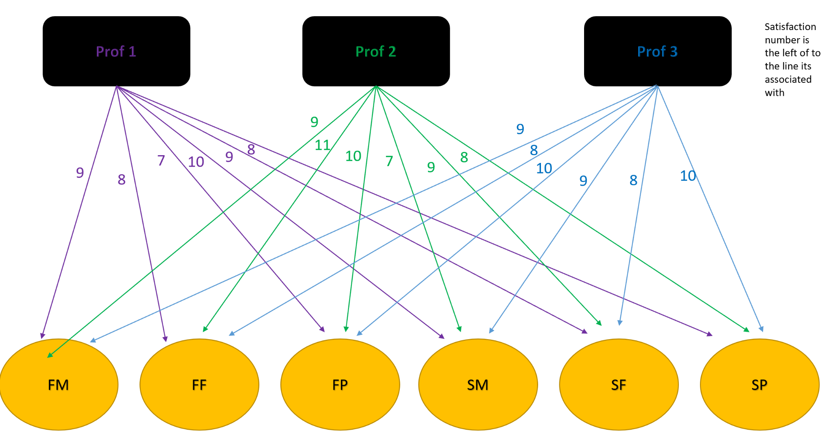

Purple is professor 1

Green is professor 2

Blue is professor 3

PART B:

| Professor 1   * FM1 = 1 * FF1 = 0 * FP1 = 0 * SM1 = 3 * SF1 = 0 * SP1 = 0 | Professor 2   * FM2 = 0 * FF2 = 3 * FP2 = 0 * SM2 = 0 * SF2 = 1 * SP2 = 0 | Professor 3   * FM3 =0 * FF3 = 0 * FP3 = 3 * SM3 = 0 * SF3 = 0 * SP3 = 1 |
| --- | --- | --- |

Objective Function = **121**

Please look at my python attached file for this problem.

# Problem 5

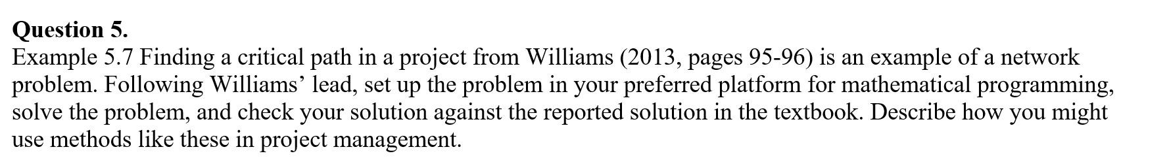

To = 0

T1 = 4

T2 = 17

T3 = 7

T4 = 17

T5 = 22

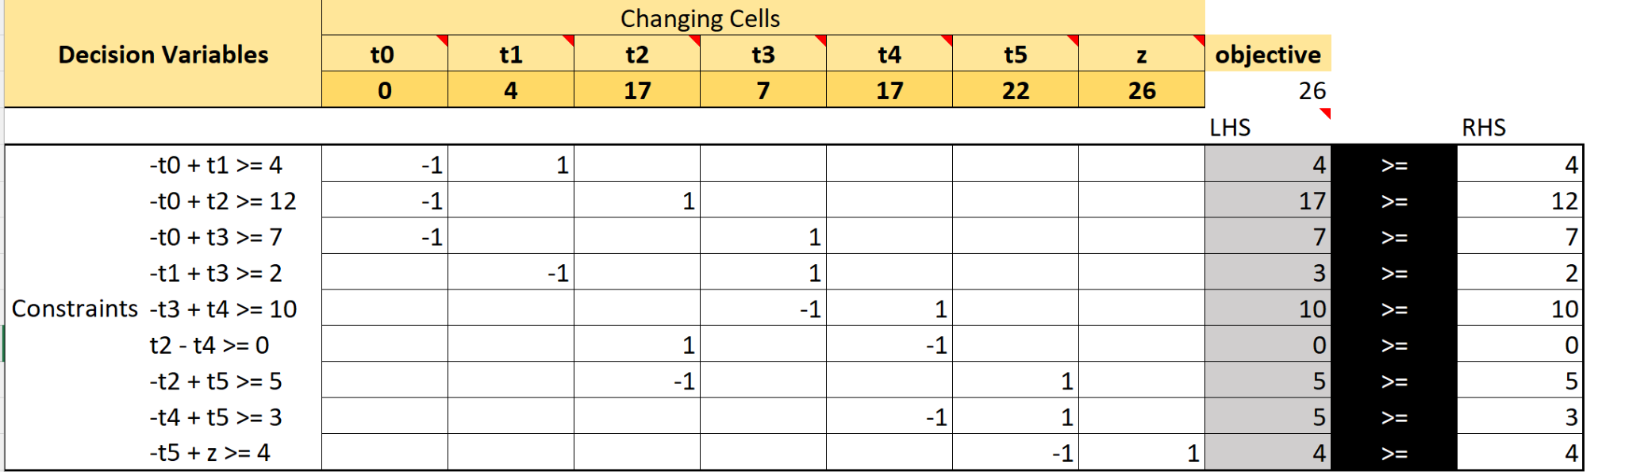

My answer matches that of the textbook's answer.

I could see using these methods in project management to see the fastest way to get the overall job done. When there are delays to tasks being completed it could have a domino effect & severely slow down the end date and be costly. The order of completing tasks matters and when they’re multiple options or avenues to take it can be too hard to distinguish the best route by logic or without computer software. This tool allows project managers speeds and accuracy to decision making.